**East West University**

**Department of CSE**

**Lab Report 03**

**CSE 438**

**Digital Image Processing**

**Submitted To:**

Md. Mahir Ashhab

Lecturer

Department of Computer Science and Engineering

**Submitted By:**

Adri Saha

ID: 2019-1-60-024

Submission Date: 14 August 2022

**Histogram report**

First, we took an image ‘cats’,

img= cv.imread('cats.jpg')

cv.imshow('cats',img)

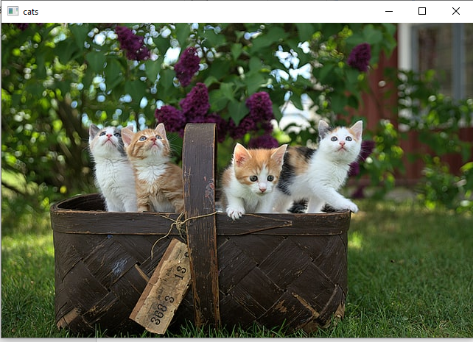

Figure: Real image

Converted it into grayscale image,

gray= cv.cvtColor(img,cv.COLOR_BGR2GRAY)

cv.imshow('grayscale',gray)

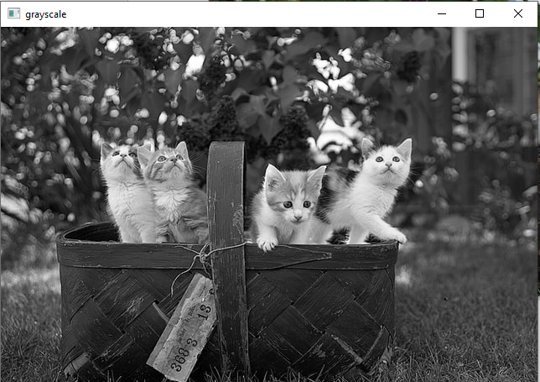

Figure: Grayscale image

**Plot grayscale histogram:**

hist = cv.calcHist([gray],[0], None,[256],[0,256])

plt.plot(hist,color='black')

Figure: grayscale histogram

**Explanation**: It represents, this is a darker image. Because we see there are high intensity on between 0 to 100 pixels which represents darker green color or pixels are mostly seen on this image. This image is not brighter or lighter. Here pixels are mostly seen on darker side. Not equally distributed.

**Colored image histogram:**

**For blue:**

blue_hist = cv.calcHist([img],[0], None, [256], [0,256])

plt.plot(blue_hist,color='blue')

**For red:**

red_hist = cv.calcHist([img],[2], None, [256], [0,256])

plt.plot(red_hist,color='red')

**For green:**

green_hist = cv.calcHist([img],[1], None, [256], [0,256])

plt.plot(green_hist,color='green')

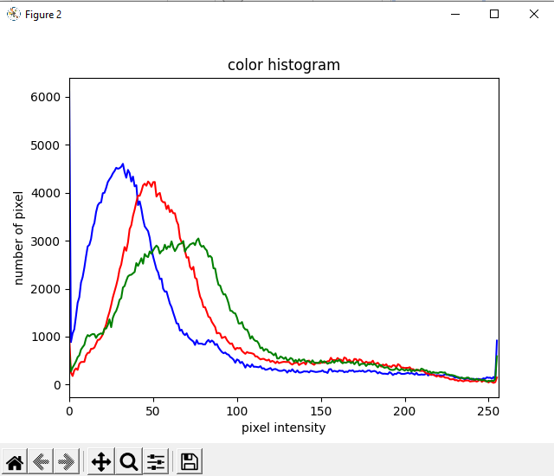

**Figure:** Colored histogram

**Explanation**: It represents, in this colored image red & blue color is absent. That is why, intensity of red & blue is very low & so it is on the left side where intensity has between 0 and 100. But there are some green colors on this picture that is why green line has more pixel intensity than red & blue. There is darker shaded green are mostly seen on this picture.

**Now finding intensity of red, blue, green (single channel) of this picture:**

blank= np.zeros(img.shape[:2],dtype='uint8')

b,g,r= cv.split(img)

blue= cv.merge([b, blank, blank])

green= cv.merge([b, g, blank])

red= cv.merge([blank, blank, r])

**Single channel output:**

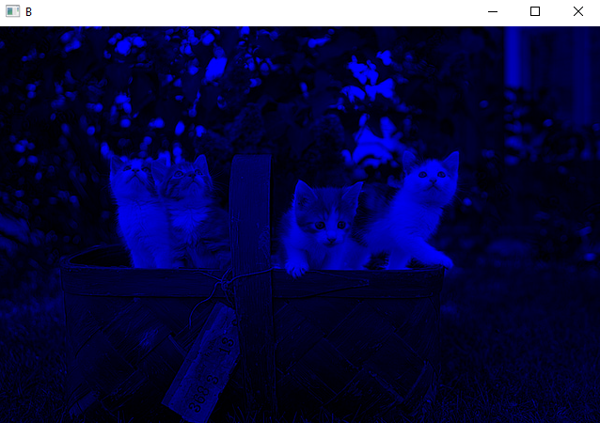 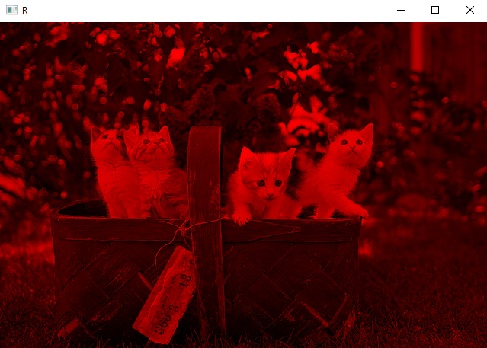

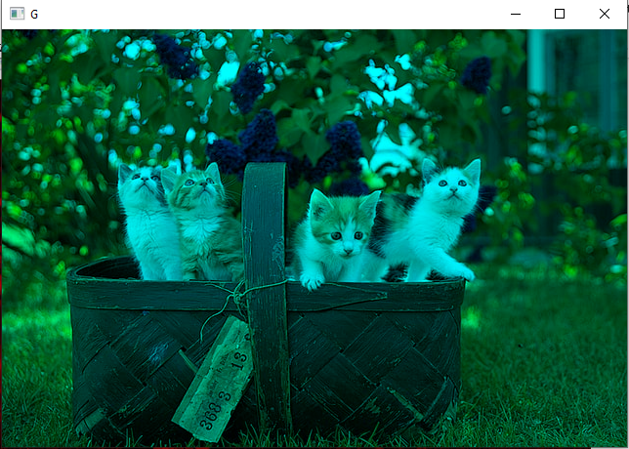

Single channel output

blue_hist = cv.calcHist([blue],[0], None, [256], [0,256])

plt.plot(blue_hist,color='blue')

red_hist = cv.calcHist([red],[2], None, [256], [0,256])

plt.plot(red_hist,color='red')

green_hist = cv.calcHist([green],[1], None, [256], [0,256])

plt.plot(green_hist,color='green')

So, here we find the same histogram. That’s why we can say we calculated the histogram correctly here.

**2nd image: cat**

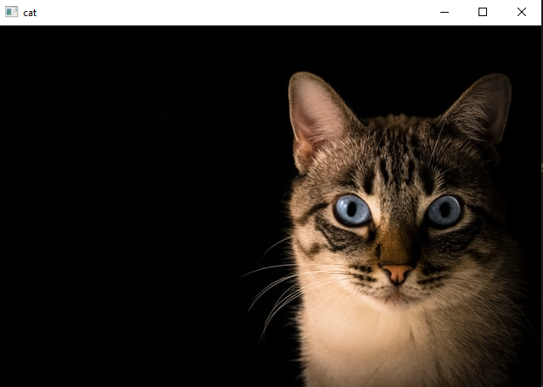

In this picture, we find no RGB values. That’s why all are null & on left side. Also, it represents a very dark picture. There are almost 0 color pixel. No RGB color are shown in this picture. On left side there are some pixels where pixel intensity is 0.

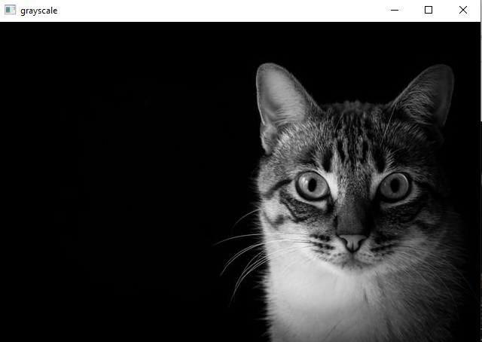

As it is a very darker image, there are almost no pixel in grayscale picture too.

**3rd image: cat_large**

It also represents a darker side image which have almost no pixel intensity. Only very few pixels (green line) are seen in left side.

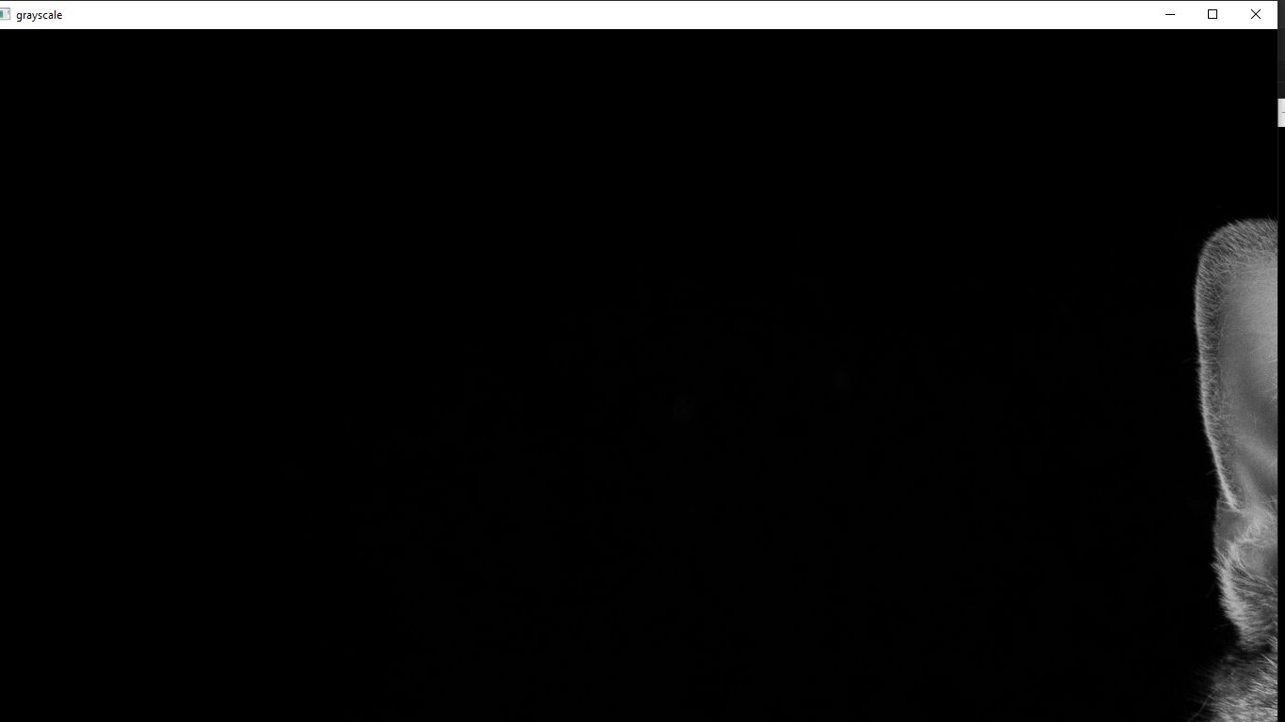

As this image is full black, it shows no RGB pixel.

**4th image: cats 2**

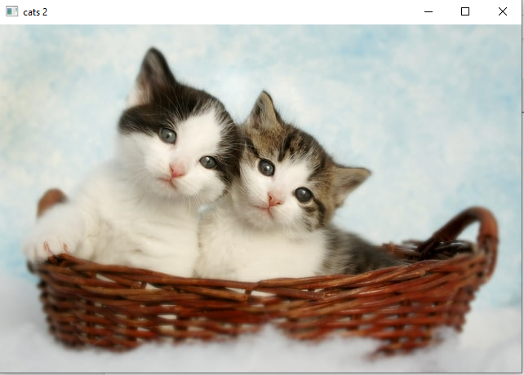

This is a very light picture. Here white color is mostly seen. It is a bright picture & so pixel intensity is very good and on the left side. That is why, on right side 200 to 250 R,G,B all plots in high. We know, on a white picture, red, blue, green all is present. So, intensity are on right side. On high intensity pixel number is also high.

In this grayscale image, there are many white colors seen. So, there are more pixels on 200 to 250 intensity which means high intensity pixels are shown on this picture. So, it represents a light picture.

**5th image: group 1**

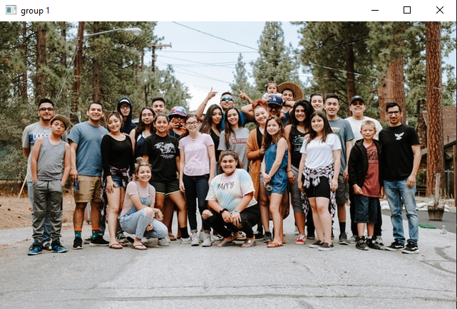

In this graph, we see pixels are almost uniform distributed almost every side equally. On right side pixels are little high than left side. On 200, pixels intensity is high which represents lighter shaded color of red, green & blue. So from this graph we can say lighter sided RGB colors are seen accurately.

On this graph, we see high pixel intensity on right side. So, it represents lighter image more than darker side.

**6th image: group 2**

On this image, we see all pixels are in right side. Which represents lighter shaded color as intensity is high on 250 point. So, we can see it is a very bright & light image. Blue wave is above than red & green which means light blue color is taking maximum portion on this image.

By this picture, we can say white color is highly shown as pixel number is so high intensity on 250. So, it is a light image.

**7th image: lady**

In this image, we see high green pixel is on left side where intensity is so low. And then RGB color intensity are equally distributed on leftside which is very low. So, we can say, there has darker shaded green and lighter shaded red, blue pixels are seen. So overall it is a little darker image.

In this graph, there are more pixels on low intensity which presents darker side. So black color is mostly seen in this picture. It is a darker image as well.

**8th image: park**

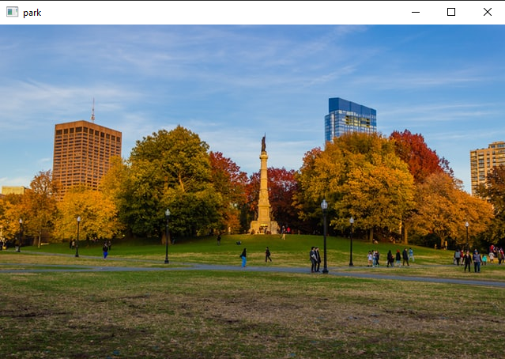

From this graph, we can say there has some lighter blue pixels as blue pixel intensity is high in between 200 & 250. Medium shaded red and green are also seen. Light blue color is seen on some pixels. So, we can say it is a quite bright or light image.

In this graph, we see darker area is larger than lighter area. But though lighter area is small but on higher than darker area. So, we can say, in this picture, there are many darker black sides has shown but not totally black. We can say dark grey color are shown mostly. And has some lighter value on right side. It means lighter area are small, but the area is too light than darker. On high intensity or lighter side pixels are higher than darker side pixels. So, it is between lighter and darker shaded image.